F&G Primary SCITT Class Teacher Mentor Interim Programme Evaluation Spring 2021
Name:
Feedback | Strongly agree | Agree | Disagree | Strongly disagree | Comments
Curriculum

The SCITT curriculum, including SCITT training and fortnightly target themes, has a coherent and sequential design which relates to how trainees learn and develop through the ITT year.

The trainee has been supported to apply the SCITT taught curriculum (Friday training) to their classroom practice (through sharing the notable elements document).

The trainee has been supported to apply their academic reading and writing (PGCE) to their classroom practice.

The trainee timetable is aligned with the school placement half-termly expectations.

The SCITT curriculum (SCITT training and school experiences) have provided opportunities for trainees to make progress against the five core curriculum areas.
- Behaviour Management
- Pedagogy
- Curriculum
- Assessment
- Professional Behaviours

The SCITT curriculum (SCITT training and school experiences) have provided opportunities for trainees to make progress against identified local priorities:
- Culture and climate
- Language and communication
- Meeting the needs of individuals
- SEND

The four SCITT key principles are integrated through the programme.
- Evidence informed
- Coherent
- Personalised
- High Quality

I have applied the SCITT effective mentoring approaches when supporting my trainee.

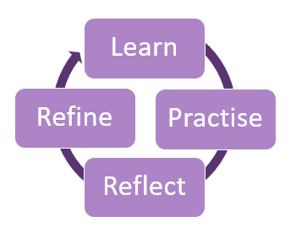

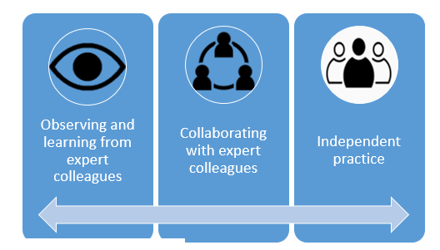

I have a good understanding of the new ITT Core Content Framework (Learn how to ……. statements).

I understand that the ITT Core Content Framework and the Early Career Framework from a three-year package to support Early Career Teachers.

Formative assessment and feedback

I am effectively setting SMART targets with my trainee in-line with the fortnightly target themes.

There is sufficient challenge within the fortnightly targets to maximise trainee progress.

The action steps to support the meeting of targets are logical, sequenced and broken down to support the ‘learn-practise-reflect-refine’ model.

I have applied ‘instructional coaching’ strategies to target setting actions steps e.g. practise and feedback in low stakes environments, identifying highest leverage development points

SCITT feedback on target setting is supportive and developmental.

Time is provided for preparation and reflection (mentors and trainees) prior to formal lesson observation feedback.

The learning conversation feedback utilises effective questioning and is centred around trainee reflections rather than a narrative account of the lesson.

The spring Teachers’ Standards Tracking Profile (TSTP) is accurately completed and used as a formative assessment tool to inform next steps for development through target setting, (and where necessary, appropriate intervention).

‘Role of the mentor’ training and CPD
Induction training supported my understanding of the SCITT programme and preparation for the role of the mentor.

I engage with the SCITT Handbook, Class Teacher Mentor Handbook and the on-line resources from the SCITT website to support my role as a mentor.

The NASBTT certification on ‘effective coaching and mentoring’ has prepared me for the mentoring role.

SCITT based training and development have supported my understanding of the expectations of the SCITT mentor role.

Feedback received through the QA visit process has supported my mentoring development.

SCITT communication is timely, helpful and informative.

Optional mentor coffee and catch up sessions are welcome.

I have engaged with the NASBTT TEMZ resource through the NASBTT website.

I have engaged with the books provided by SCITT to support the understanding of curriculum and mentoring role.

I have engaged with the recommended reading and resources outlined in SCITT training and weekly messages.

Summative assessment
The summer Teachers’ Standards Tracking Profile (TSTP) is accurately completed as a final summative assessment which will be used to inform recommendation for Qualified Teacher Status (QTS).

The Early Career NQT transition report is accurately completed to inform a continuum of trainee development for the two year NQT period.

Wellbeing
Through the mentoring role, the trainee is supported, through modelling and discussion, to develop positive working practices, including managing workload, to ensure wellbeing.

The trainee has applied new learning and development from SCITT training, focusing on wellbeing and managing workload strategies, to their practice.

The SCITT programme works to minimise unnecessary workload associated with the mentoring role.

The SCITT have provided opportunities for reflection and development, relating to wellbeing and managing workload, for the role of the mentor.

COVID-19 Adaptations
Communication from SCITT regarding COVID-19 has been prompt, clear and helpful, for example, changes to school placements and range of professional experience.
Electronic submission of SCITT documents is quick, simple and straightforward.

The induction recording (available from July 2020) provided the necessary details to enable an effective start to the programme in September.

SCITT mentor and NASBTT training sessions were effectively delivered through a live video conference platform.

The SCITT have demonstrated appropriate flexibility, and realistic expectations of the programme have been applied whilst maintaining high standards.

Trainees have developed supportive networks with fellow cohort members.

On-line QA visits were rigorous and supportive in their amended format.

Additional 1:1 calls in September were useful.

Overall, I have felt informed, well-supported and continue to enjoy the SCITT mentoring role.

Any other comments
Please draw our attention to any other strengths or areas for development you would like us to be aware of to support further developments.

